Basic writing and formatting syntax

Create sophisticated formatting for your prose and code on GitHub with simple syntax.

In this article:

[Headings](https://help.github.com/articles/basic-writing-and-formatting-syntax/#headings)

[Styling text](https://help.github.com/articles/basic-writing-and-formatting-syntax/#styling-text)

[Quoting text](https://help.github.com/articles/basic-writing-and-formatting-syntax/#quoting-text)

[Quoting code](https://help.github.com/articles/basic-writing-and-formatting-syntax/#quoting-code)

[Links](https://help.github.com/articles/basic-writing-and-formatting-syntax/#links)

[Section links](https://help.github.com/articles/basic-writing-and-formatting-syntax/#section-links)

[Relative links](https://help.github.com/articles/basic-writing-and-formatting-syntax/#relative-links)

[Lists](https://help.github.com/articles/basic-writing-and-formatting-syntax/#lists)

[Task lists](https://help.github.com/articles/basic-writing-and-formatting-syntax/#task-lists)

[Mentioning people and teams](https://help.github.com/articles/basic-writing-and-formatting-syntax/#mentioning-people-and-teams)

[Referencing issues and pull requests](https://help.github.com/articles/basic-writing-and-formatting-syntax/#referencing-issues-and-pull-requests)

[Using emoji](https://help.github.com/articles/basic-writing-and-formatting-syntax/#using-emoji)

[Paragraphs and line breaks](https://help.github.com/articles/basic-writing-and-formatting-syntax/#paragraphs-and-line-breaks)

[Ignoring Markdown formatting](https://help.github.com/articles/basic-writing-and-formatting-syntax/#ignoring-markdown-formatting)

**Headings**

To create a heading, add one to six # symbols before your heading text. The number of # you use will determine the size of the heading.

# The largest heading

## The second largest heading

###### The smallest heading

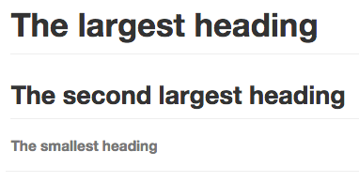

**Styling text**

You can indicate emphasis with bold, italic, or strikethrough text.

| **Style** | **Syntax** | **Keyboard shortcut** | **Example** | **Output** |
| --- | --- | --- | --- | --- |
| Bold | ** ** or __ __ | command/control + b | **This is bold text** | **This is bold text** |
| Italic | * * or _ _ | command/control + i | *This text is italicized* | *This text is italicized* |
| Strikethrough | ~~ ~~ |  | ~~This was mistaken text~~ | This was mistaken text |
| Bold and italic | ** **and _ _ |  | **This text is _extremely_ important** | **This text is *extremely*important** |

**Quoting text**

You can quote text with a >.

In the words of Abraham Lincoln:

> Pardon my French

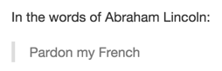

**Tip:** When viewing a conversation, you can automatically quote text in a reply by highlighting the text, then typing r. For more information, see "[Using keyboard shortcuts](https://help.github.com/articles/using-keyboard-shortcuts/)."

**Quoting code**

You can call out code or a command within a sentence with single backticks. The text within the backticks will not be formatted.

Use `git status` to list all new or modified files that haven't yet been committed.

Rendered inline code block

To format code or text into its own distinct block, use triple backticks.

Some basic Git commands are:

```

git status

git add

git commit

```

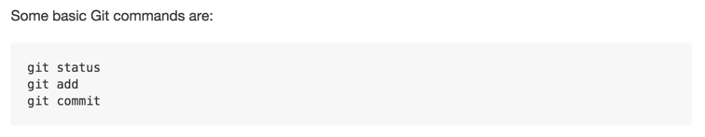

For more information, see "[Creating and highlighting code blocks](https://help.github.com/articles/creating-and-highlighting-code-blocks)."

**Links**

You can create an inline link by wrapping link text in brackets [ ], and then wrapping the URL in parentheses ( ). You can also use the keyboard shortcut command + k to create a link.

This site was built using [GitHub Pages](https://pages.github.com/).

Rendered link

**Tip:** GitHub automatically creates links when valid URLs are written in a comment. For more information, see "[Autolinked references and URLS](https://help.github.com/articles/autolinked-references-and-urls)."

**Section links**

You can link directly to a section in a rendered file by hovering over the section heading to expose the link:

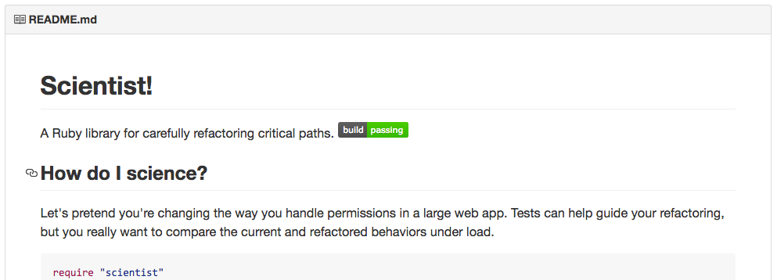

**Relative links**

You can define relative links and image paths in your rendered files to help readers navigate to other files in your repository.

A relative link is a link that is relative to the current file. For example, if you have a README file in root of your repository, and you have another file in *docs/CONTRIBUTING.md*, the relative link to *CONTRIBUTING.md* in your README might look like this:

[Contribution guidelines for this project](docs/CONTRIBUTING.md)

GitHub will automatically transform your relative link or image path based on whatever branch you're currently on, so that the link or path always works. You can use all relative link operands, such as ./and ../.

Relative links are easier for users who clone your repository. Absolute links may not work in clones of your repository - we recommend using relative links to refer to other files within your repository.

**Lists**

You can make an unordered list by preceding one or more lines of text with - or *.

- George Washington

- John Adams

- Thomas Jefferson

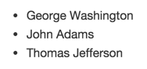

To order your list, precede each line with a number.

1. James Madison

2. James Monroe

3. John Quincy Adams

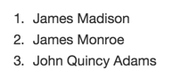

**Nested Lists**

You can create a nested list by indenting one or more list items below another item.

To create a nested list using the web editor on GitHub or a text editor that uses a monospaced font, like [Atom](https://atom.io/), you can align your list visually. Type space characters in front of your nested list item, until the list marker character (- or *) lies directly below the first character of the text in the item above it.

1. First list item

- First nested list item

- Second nested list item

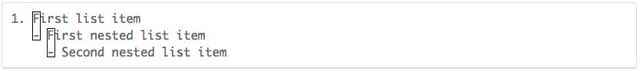

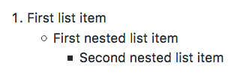

To create a nested list in the comment editor on GitHub, which doesn't use a monospaced font, you can look at the list item immediately above the nested list and count the number of characters that appear before the content of the item. Then type that number of space characters in front of the nested list item.

In this example, you could add a nested list item under the list item 100. First list item by indenting the nested list item a minimum of five spaces, since there are five characters (100.) before First list item.

100. First list item

- First nested list item

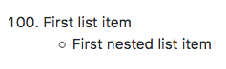

You can create multiple levels of nested lists using the same method. For example, because the first nested list item has seven spaces (␣␣␣␣␣-␣) before the nested list content First nested list item, you would need to indent the second nested list item by seven spaces.

100. First list item

- First nested list item

- Second nested list item

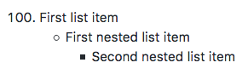

For more examples, see the [GitHub Flavored Markdown Spec](https://github.github.com/gfm/" \l "example-265).

**Task lists**

To create a task list, preface list items with [ ]. To mark a task as complete, use [x].

- [x] Finish my changes

- [ ] Push my commits to GitHub

- [ ] Open a pull request

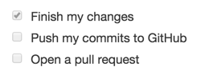

If a task list item description begins with a parenthesis, you'll need to escape it with \:

- [ ] \(Optional) Open a followup issue

For more information, see "[About task lists](https://help.github.com/articles/about-task-lists)."

**Mentioning people and teams**

You can mention a person or [team](https://help.github.com/articles/setting-up-teams/) on GitHub by typing @ plus their username or team name. This will trigger a [notification](https://help.github.com/articles/about-notifications) and bring their attention to the conversation. People will also receive a notification if you edit a comment to mention their username or team name.

@github/support What do you think about these updates?

Rendered @mention

When you mention a parent team, members of its child teams also receive notifications, simplifying communication with multiple groups of people. For more information, see "[About teams](https://help.github.com/articles/about-teams)."

Typing an @ symbol will bring up a list of people or teams on a project. The list filters as you type, so once you find the name of the person or team you are looking for, you can use the arrow keys to select it and press either tab or enter to complete the name. For teams, enter the @organization/team-name and all members of that team will get subscribed to the conversation.

The autocomplete results are restricted to repository collaborators and any other participants on the thread.

**Referencing issues and pull requests**

You can bring up a list of suggested issues and pull requests within the repository by typing #. Type the issue or pull request number or title to filter the list, and then press either tab or enter to complete the highlighted result.

For more information, see "[Autolinked references and URLs](https://help.github.com/articles/autolinked-references-and-urls)."

**Using emoji**

You can add emoji to your writing by typing :EMOJICODE:.

@octocat :+1: This PR looks great - it's ready to merge! :shipit:

Rendered emoji

Typing : will bring up a list of suggested emoji. The list will filter as you type, so once you find the emoji you're looking for, press **Tab** or **Enter** to complete the highlighted result.

For a full list of available emoji and codes, check out [emoji-cheat-sheet.com](http://emoji-cheat-sheet.com/).

**Paragraphs and line breaks**

You can create a new paragraph by leaving a blank line between lines of text.

**Ignoring Markdown formatting**

You can tell GitHub to ignore (or escape) Markdown formatting by using \ before the Markdown character.

Let's rename \*our-new-project\* to \*our-old-project\*.

Rendered escaped character

For more information, see Daring Fireball's "[Markdown Syntax](https://daringfireball.net/projects/markdown/syntax#backslash)."

**Further reading**

"[About writing and formatting on GitHub](https://help.github.com/articles/about-writing-and-formatting-on-github)"

"[Working with advanced formatting](https://help.github.com/articles/working-with-advanced-formatting)"

"[Mastering Markdown](https://guides.github.com/features/mastering-markdown/)"

[**Contact a human**](https://github.com/contact)